- Questions for Engaging a Leadership Conversation
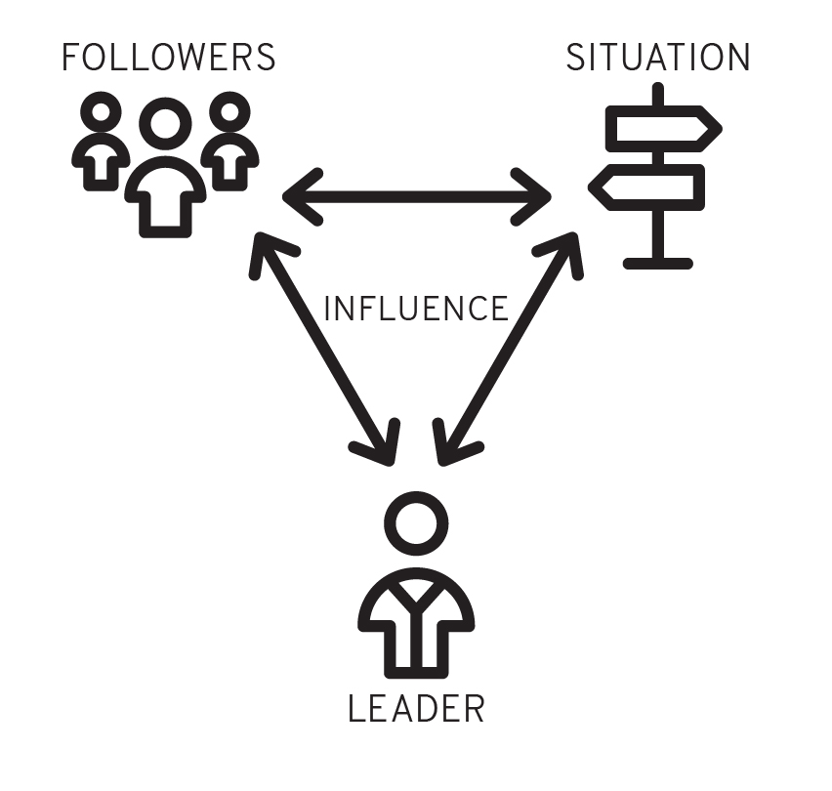
1.) Who is the leader? What can we learn about his/her capacity in terms of talents, skills, and spiritual gifts? What can we learn about his/her sense of responsibility for leadership?

2.) Who are the followers? What can we learn about followership in terms of: a) their loyalty to the leader; b) their acceptance of the leader’s God-inspired vision; c) their willingness to serve and sacrifice to accomplish that vision; d) their responsiveness to correction or discipline; and e) the quality of relationships they have with each other and with the leader?

3.) What is the leadership situation in terms of the Leadership Era? How does it affect the followers’ expectations? What leadership functions—task, relationship, or inspiration—does the leader provide?

4.) How does the leader attempt to gain influence with followers? Does the leader influence followers toward God’s purposes?

5.) What leadership insights, principles, and values can be observed? What are the results of the leader’s actions? How would the followers have evaluated the leader’s performance?

6.) Are there any transferable principles to be gleaned from the leadership situation? How might leaders apply these principles today?

